ESU2023
WELCOME TO ESTONIA
Tartu University
Tallinn University of Technology

ESU 2023 in Estonia takes place from 27 August to 02 September 2023
Tartu University and Tallinn University of Technology are happy to welcome you to the ESU 2023 Conference and Doctoral Programme from 27 August to 02 September 2023. The first two days are held at the University of Tartu. Buses will take everyone to Tallinn on Tuesday evening, 29.08 to continue in Tallinn.
Transport: from both Tallinn Airport and Tallinn Port there are direct busses to Tartu. Check for schedule and tickets: https://www.tpilet.ee/en/

27.08. ARRIVING TO TARTU
Tartu is the second largest city in Estonia and is considered the artistic, cultural, financial, economic and social centre of southern Estonia, being also European cultural capital in 2024.

All distances between hotels and (venue) University of Tartu are ca 15 min walking.

Recommended hotels in tartu
Hotel name | Address | Price per night* | Contact
SOHO | Rüütli 9, 51005 Tartu | Single 80 € Double 90 € | https://www.hotellsoho.ee/en/  sales@hotellsoho.ee;  code: ESU2023
DORPAT | Soola 5, 51004 Tartu | Single 59 €  Double 70 € | https://hotelwebsitebooking.com/dorpat/rooms  info@dorpat.ee  code: ESU 2023
ART HOTEL PALLAS | Riia 4, 51004 Tartu | Single 70 €  Double 80 € | https://pallas.tartuhotels.ee/  pallas@tartuhotels.ee  code: ESU 2023
- Breakfast is included in all hotels
27.08. WELCOME EVENT
At the Museum of Tartu University, white hall 17.00 – 20.00
Lossi 25, 51003 Tartu, https://muuseum.ut.ee/en

Hotels at the map:
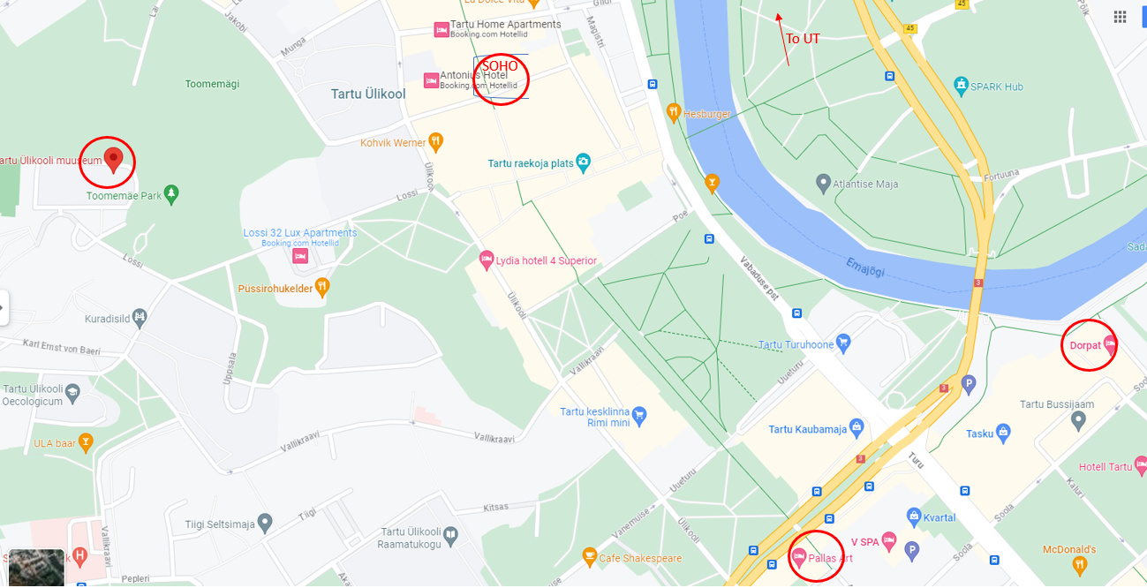

29.08. ARRIVING TO TALLINN
Tallinn is a capital of Estonia with its mediaeval and Hanseatic origin Old Town inscribed as a UNESCO World Heritage Site.
Transport: from Tallinn Airport there is direct tram line to the city centre. Or you can take a taxi to the hotel. Taxi from the Centre of Tallinn (or hotel) to the Tallinn University of Technology will cost around 15 eur.
Recommended hotels in tallinn
In Tallinn we offer one Campus hotel (Larsen) close to University and two hotels close to old town (ca 25 min. by trolleybus to University). Hotels at the map:
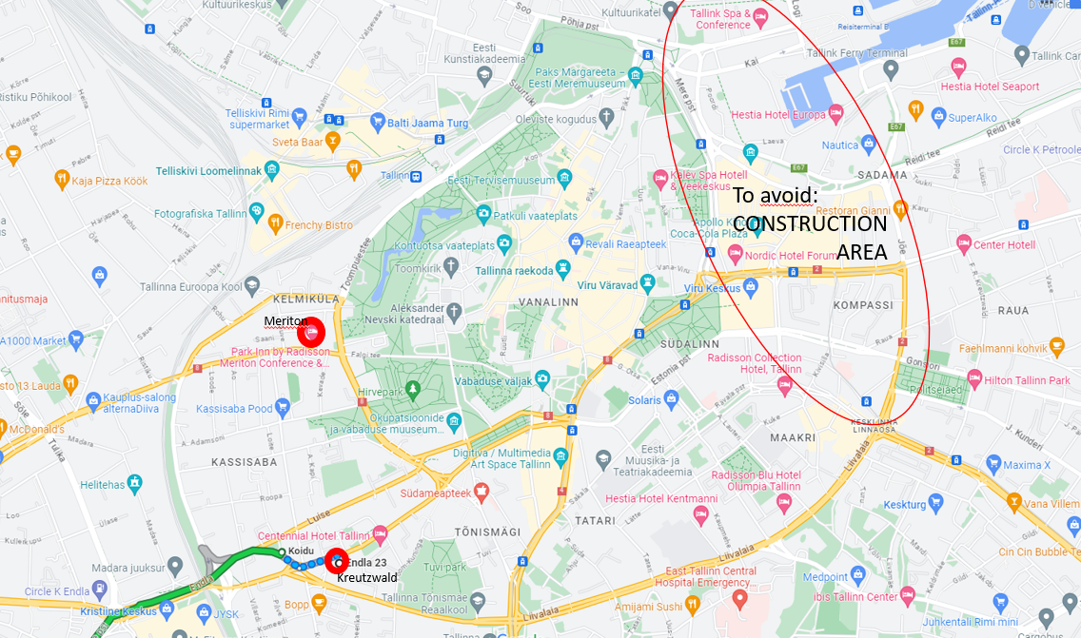

Hotel name | Address | Price per night* | Contact
KREUTZWALD | Endla 23, 10122 Tallinn | From Website price -15% | https://www.kreutzwaldhotel.com/  angela.saluste@uhotelsgroup.com  code: ESU2023
MERITON  (Park Inn Radisson) | 27 Toompuiestee, Paldiski mnt 4, 10149 Tallinn | Single 73 €  Double 83 € | https://stayatspa.ee/spad/meriton-spa-hotel-tallinn/  andra.margus@parkinn.com  code: ESU2023
Campus House  LARSEN | Akadeemia tee 32b, 12611 Tallinn | Limited space, ask from Larsen | https://larsen.ee/majad/campus-house booking@larsen.ee  code: ESU2023
- Breakfast is included in all hotels

2.09. Saturday cultural event
Sweet smells of bog and birdsong
Ööbiku Gastronomiatalu (Gastronomy farmstead) is surrounded by the beautiful endless bogs and forests of Raplamaa. In a couple of hours of walking, you will be able to experience unparalleled positive emotions and experiences, which are good to impress together at the dining table of the Ööbiku resto after the hike. We can find a suitable hiking trail for both the beginner hiker and the experienced hiker. A good hiking experience in the forest is ensured by suitable shoes and clothes for the hike, such as high-legged rubber boots and clothing suitable for the weather.

